

**Year 11 ATAR Human Biology**

**AEHBY**

**Task 2: Mid Semester 1 Test**

**Multiple Choice Questions Booklet**

**Multiple Choice Section 15 Marks**

1. Which of the following consist of a network of intracellular membranes with attached ribosomes?

a) rough endoplasmic reticulum

b) smooth endoplasmic reticulum

c) mitochondria

d) Golgi apparatus

1. The nucleus stores the DNA needed to synthesise which of the following molecules in the cytoplasm?

a) carbohydrates

b) lipids

c) proteins

d) phospholipids

1. If a cell lacked ribosomes, it would not be able to

a) move

b) synthesise proteins

c) produce DNA

d) metabolise sugars

1. Mammalian sperm cells expend a large amount of energy in moving through the female reproductive tract. On the basis of this information you would predict that these cells would contain a large number of:
   1. vacuoles
   2. mitochondria
   3. ribosomes
   4. chloroplasts
2. In facilitated diffusion;
3. transport is quicker than normal diffusion
4. transport is selective
5. transport of one substance is stopped by another
6. all of the above
7. Which of the following substances catalyses the body’s chemical reactions?
8. enzymes
9. substrates
10. ribosomes
11. hormones
12. What type of tissue lines surfaces?
13. Muscle tissue
14. Nervous tissue
15. Connective tissue
16. Epithelial tissue
17. Oxygen always moves across plasma membranes by the pocess of:
18. Facilitated diffusion
19. Endocytosis
20. Osmosis
21. Simple diffusion
22. The concentration of oxygen is greater in inhaled air compared with exhaled air because it
23. is actively transported from the capillaries to the alveoli.
24. diffuses from the capillaries into the alveoli due to its concentration in the blood being higher than in the lungs.
25. diffuses from the alveoli into the capillaries due to its concentration in the blood being lower than in the lungs.
26. moves from the capillaries into the alveoli due to changes in carbon dioxide concentrations.
27. Listed below are some of the events that occur during the cardiac cycle:
28. Ventricles fill.
29. Ventricles contract, atrioventricular valves close.
30. Atria contract.
31. Semilunar valves close.

What is the correct order of events during the cardiac cycle?

1. iii, i, ii, iv.
2. i, iii, ii, iv.
3. iv, iii, ii, i.
4. iii, i, iv, ii.
5. What is the correct order of cell organisation?

a) Cells 🡪 tissues 🡪 systems 🡪 organs 🡪 organsism

b) Tissues 🡪 cells 🡪 organs 🡪 systems 🡪 organism

c) Cells 🡪 tissues 🡪 organs 🡪 systems 🡪 organism

e) Cells 🡪 tissues 🡪 organs 🡪 organism 🡪 systems

1. Consider the following diagram, then identify which of the following statements about the diagram is CORRECT.

A

a) oxygen would move from A to B by active transport and carbon dioxide would move from B to A by diffusion

b) carbon dioxide would move from B to A by active transport and oxygen would move from B to A by diffusion

c) both oxygen and carbon dioxide would move between A and B by diffusion

d) both oxygen and carbon dioxide would move between A and B by osmosis

1. During the process of expiration the:
2. diaphragm lowers
3. ribs move upwards and outwards
4. size of the thoracic cavity increases
5. pressure inside the thoracic cavity increases
6. Metabolism can be described as:

a) the sum of all chemical reactions in the body

b) anabolic reactions that produce energy

c) anaerobic and aerobic respiration

d) catabolic reactions that release energy.

1. Which of the following lists has an anabolic process followed by a catabolic process?

|  |  |  |
| --- | --- | --- |
|  | **Anabolic process** | **Catabolic process** |
| a) | Respiration | Protein synthesis |
| b) | Protein synthesis | Fat digestion |
| c) | Anaerobic respiration | DNA replication |
| d) | Anaerobic respiration | Aerobic respiration |



**Year 11 ATAR Human Biology**

**Task 2: Mid Semester 1 Test**

**Answer Booklet**

Time Allocated: 50 minutes

Weighting 12.5%

**Name: ___________________________________________**

|  |  |  |  |
| --- | --- | --- | --- |
| **Multiple Choice** | **Short Answer** | **Extended Answer** | **Total** |
| /15 | /30 | /12 | /57 |

**SECTION ONE:**

Multiple choice answers. Cross (X) through the correct answer.

|  |  |  |  |  |
| --- | --- | --- | --- | --- |
| **1** | a | b | c | d |
| **2** | a | b | c | d |
| **3** | a | b | c | d |
| **4** | a | b | c | d |
| **5** | a | b | c | d |
| **6** | a | b | c | d |
| **7** | a | b | c | d |
| **8** | a | b | c | d |
| **9** | a | b | c | d |
| **10** | a | b | c | d |
| **11** | a | b | c | d |
| **12** | a | b | c | d |
| **13** | a | b | c | d |
| **14** | a | b | c | d |
| **15** | a | b | c | d |

**Short Answer Section 30 Marks**

1. Figure 1 below refers to parts (a) to (c) of Question 16.

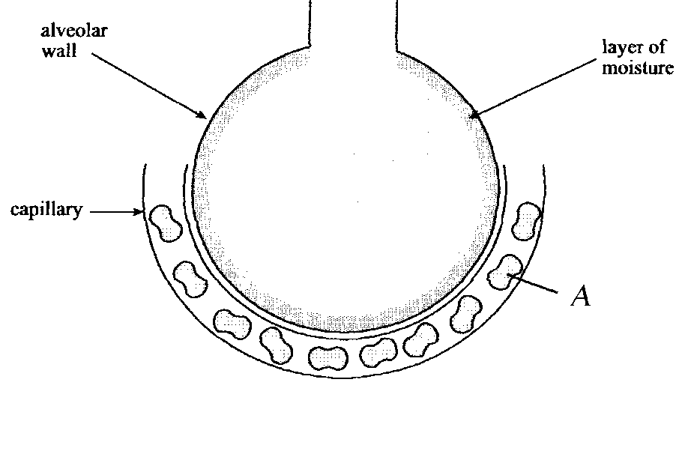Figure 1

1. State **ONE** function of the layer of moisture that lines the alveolar wall. (1 mark)

_____________________________________________________________________

_____________________________________________________________________

_____________________________________________________________________

1. State **ONE** other structural feature of the alveolar wall tissue and describe the how it facilitates efficient gas exchange. (2 marks)

_____________________________________________________________________

_____________________________________________________________________

_____________________________________________________________________

1. Name structure A, and discuss 2 roles it performs in the gas exchange in the lungs?(3 marks)

_____________________________________________________________________

_____________________________________________________________________

_____________________________________________________________________

17. A student observed changes in a red blood cell which was placed in high concentration salt water.

1. Draw in the sketches he would have seen in the boxes below: (3 marks)

Normal cell

Cell after 10mins

Cell after 30 mins

1. What is the name for this process of transportation? (1 mark)

_____________________________________________________________________

1. Explain your drawings and why the cell changes? (4 marks)

_____________________________________________________________________

_____________________________________________________________________

_____________________________________________________________________

1. a) Write the equation for cellular respiration: (1 mark)

_____________________________________________________________________

1. Name the location in the cell where each of these processes below occur. (3 marks)

|  |  |
| --- | --- |
| **Process** | **Location in the cell** |
| Glycolysis |  |
| Krebs Cycle  (citric acid cycle) |  |
| Electron transport chain |  |

19) Figure 2 below shows a cross section through the middle of the heart.

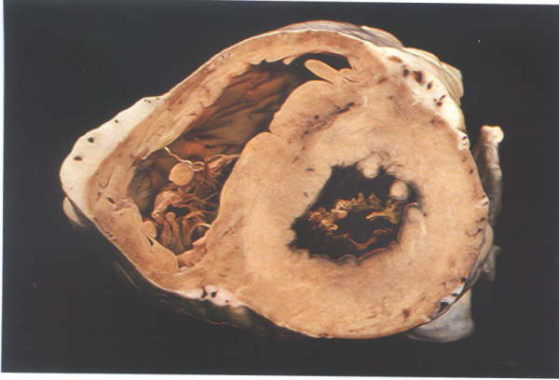

Figure 2.

1. What is the main structural difference between the right and left ventricle and explain why this is significant to their respective functions? (3 marks)

_____________________________________________________________________

_____________________________________________________________________

_____________________________________________________________________

b) Outline 2 structural and 2 functional differences between veins and arteries. (4 marks)

_____________________________________________________________________

_____________________________________________________________________

_____________________________________________________________________

_____________________________________________________________________

_____________________________________________________________________

_____________________________________________________________________

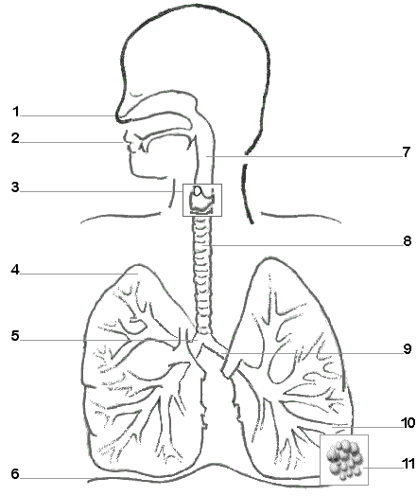

Figure 3.

20) Figure 3 above refers to parts (a) and (b) of Question 20.

a) Using the figure above, name the following parts shown: (4 marks)

|  |  |
| --- | --- |
| 1. ______________________________ | 3. _______________________________ |
| 5. _______________________________ | 6. _______________________________ |

1. Structure 8 is a tube that allows air to enter and leave the lungs at different pressures. Describe the structure that allow this to occur, without the tube collapsing. (1 mark)

_____________________________________________________________________

_____________________________________________________________________

_____________________________________________________________________

**Extended Response Section 12 Marks**

21) Enzymes are an essential component in the body which facilitate all reactions to occur at a much more efficient rate.

1. With the aid of a diagram, explain how enzymes work in an anabolic reaction (6 marks)
2. Enzymes operate efficiently in optimum conditions. Outline and explain 4 of these conditions, using the appropriate terminology. (6 marks)

__________________________________________________________________________________

__________________________________________________________________________________

__________________________________________________________________________________

__________________________________________________________________________________

__________________________________________________________________________________

__________________________________________________________________________________

__________________________________________________________________________________

__________________________________________________________________________________

__________________________________________________________________________________

__________________________________________________________________________________

__________________________________________________________________________________

__________________________________________________________________________________

__________________________________________________________________________________

__________________________________________________________________________________

__________________________________________________________________________________

__________________________________________________________________________________

__________________________________________________________________________________

__________________________________________________________________________________

__________________________________________________________________________________

__________________________________________________________________________________

__________________________________________________________________________________

**END OF ASSESSMENT**